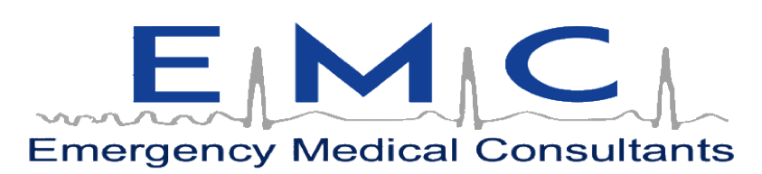
The Premier Provider Of Quality Medical Training Programs
Nationally Accredited and OSHA Programs
Medical CE Provider
Since 1988

We are excited to help you bridge over for FREE as an Instructor with the American Red Cross. Please make sure to follow the directions below, and use the attached screenshots to help ensure a smooth bridging process. If you have any questions, or challenges along with way, do not hesitate to reach out directly to our office.

Here is some general information:
1) You will need to register for each certification you have. So, if you are certified as a BLS Instructor, ACLS Instructor, and an ACLS Faculty with AHA, you will need to apply for each corresponding course with us.
2) You will be asked for your certifications for each of the course you have registered for, before the link is downloaded into your profile. Please have these ready when requested.
3) NOTED BELOW AS WELL: The first time you register for a bridge you will need to sign in on the upper left hand side as indicated below, after selecting the proper bridge.

Here are the steps to bridge with corresponding screenshots:
1) Navigate to the following website:
a. https://www.redcross.org/take-a-class
2) No need to scroll down. Simply choose from the dropdown menu for SELECT A CLASS TYPE; INSTRUCTOR TRAINING (see attached screenshot 1) and click the Red Arrow that is pointing to the right.
a. No need to change the location. This must be selected and will more than likely pull from your current location.
3) On the next pg. please click on the COURSE FORMAT box (screenshot 2) and select the box for ONLINE (screenshot 3)
a. This will filter the pg. to show you all of the bridge options (screenshot 4)
4) Select whichever bridge you would like to start with (screenshot 5). For the purposes of this explanation, I have selected BLS Instructor.
5) On the next pg. you will be asked to create all of your own personal information (screenshots 6 & 7).
6) Once filled out and completed, you will have the ability to sign-in to RCLC. www.redcrosslearningcenter.org on the home pg. (screenshot 8) under Classes I'm Taking, click on the link for the bridge you need to take. Your first step, after clicking the hyper-link will be to input your certifications. (IF YOU DO NOT HAVE YOUR PROVIDER CARD AND ONLY HAVE YOUR INSTRUCTOR, PLEASE MAKE SURE YOU SUBMIT THE INSTRUCTOR CARD AS BOTH PROVIDER AND INSTRUCTOR)
7) Once your certifications have been reviewed, you will be notified of next steps which may include logging back into the Red Cross Learning Center (RCLC) www.redcrosslearningcenter.org with the same credentials you used earlier. You will need to complete all steps as required fro the link which is easily less than an hour, and take a test (FA CPR AED instructor does not require a test).
a. NOTE AT SOME POINT IN TIME, you may be asked whether you are affiliated with an organization or not (again, this may or may not occur). If you are ever asked for this information, it is as follows:
i. Name of Organization: Emergency Medical Consultants, Inc.
ii. ORG ID (or LMS ID): EMCINFL
8) You will then be certified to Teach!
9) IF YOU HAVE OTHER BRIDGES YOU NEED TO COMPLETE, please complete steps 1-4.
10) After selecting your bridge, on the next pg. you will see a blue hyperlink on the upper left side of the pg. saying Sign Up next to Returning Customer (see screenshot 6). This will help facilitate your next steps so you do not have to enter any further information. You will also still need the proper certifications each time.
Please feel free to contact me via phone or email if you need further assistance.

